Department of Radiology Work from Home – Getting to PACS
After logging into your computer using your University Credentials, you will see your Desktop.
A window will automatically appear. Please Log into the UCHealth Citrix Gateway VPN with your University Credentials.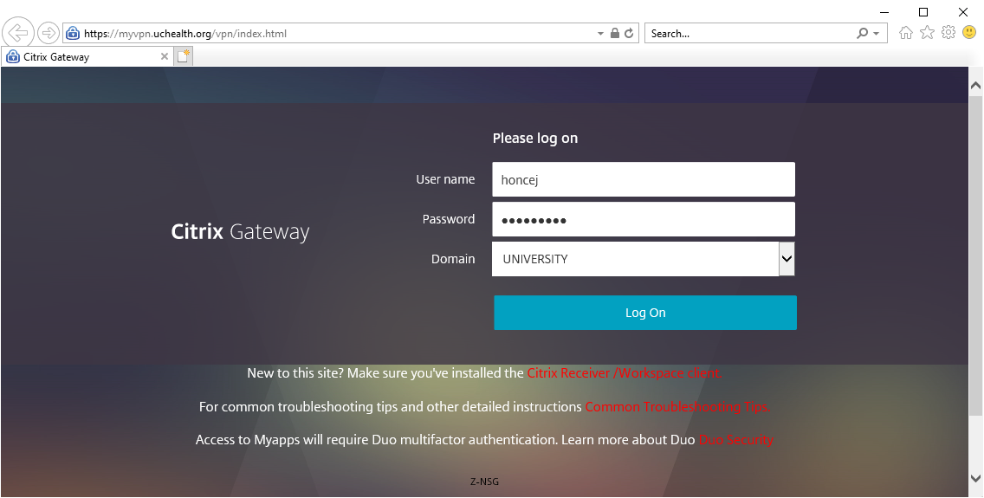
You will need to authorize your login via Duo Security Multifactor identification via your mobile device.
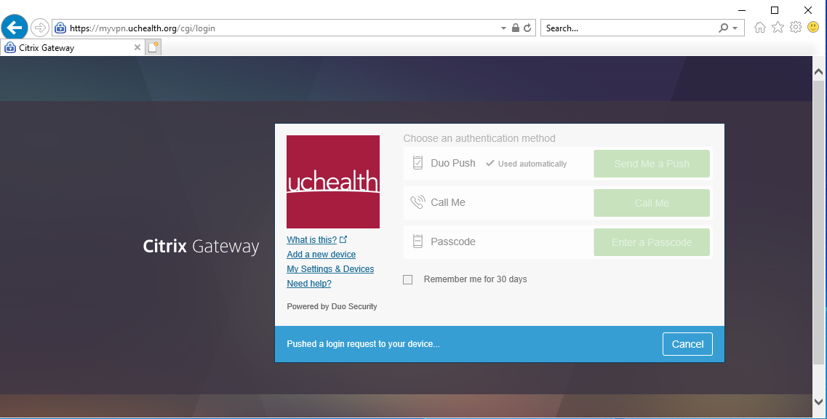
The Citrix Gateway will start connecting. Please wait until the connection has been established.
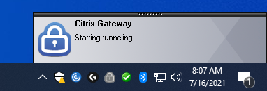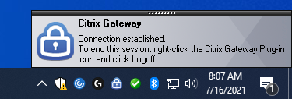
Tunnelling and establishing a connection should take no more than a few minutes. If you miss the Connection Established window, you will know you are connected if the small Lock Icon in the Tray is Blue, not Gray. Hovering your mouse over the icon will show it is connected.
Now double click the Epic Warp Drive Icon, and wait for the Epic Login Screen to pop up. You DO NOT need to login to epic manually, it just needs to be launched.
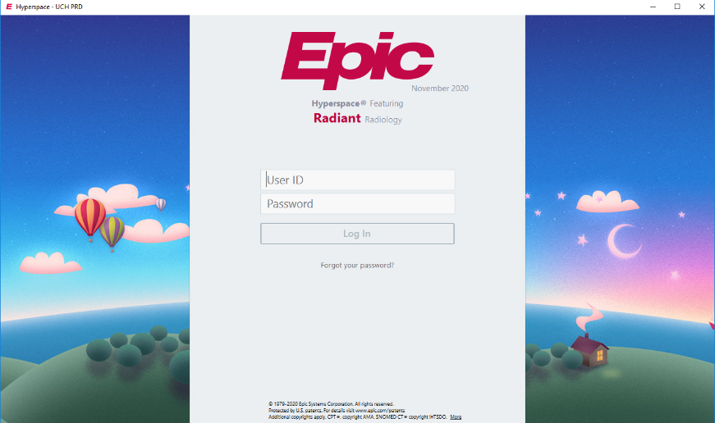
Now your ready to log into PACS as per the usual fashion, this will launch Primordial, Log into Epic and Launch Powerscribe 360. The very first time PS360 launches, you may need to click a pop letting the installer run.
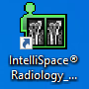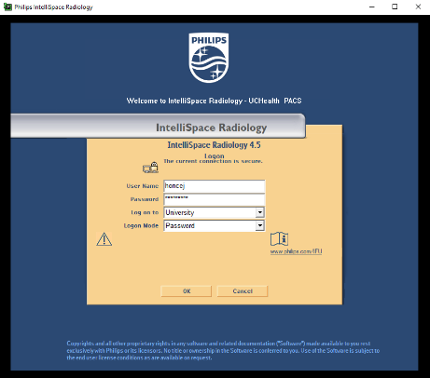

During login, this error will pop. Click OK to dismiss it.
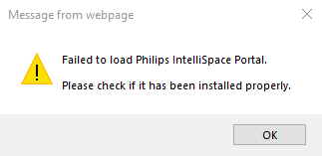

Once everything loads, you are ready to go!

